|  |  |  |
| --- | --- | --- |
|  | K. L. E. SOCIETY’S**K. L. E. INSTITUTE OF TECHNOLOGY,**Opp. Airport, Gokul, Hubballi-580 030Phone: 0836-2232681 Website: www.kleit.ac.in | **kle-logo** |

## **AICTE Activity Point Programme on**

**“DOUBLING THE INCOME OF VILLAGE BY**

**ANIMAL HUSBANDRY”**

**Group Members Visited the Site**

|  |  |  |  |
| --- | --- | --- | --- |
| **Sl. No.** | **Site Name** | **USN** | **NAME** |
|  | DOUBLING THE INCOME OF VILLAGE BY ANIMAL HUSBANDRY | 2KE20CS046 | MEGHANA TADAS |
|  | 2KE20CS099 | SONALI KATHARE |
|  | 2KE20CS085 | SEJAL SHET |
|  | 2KE20CS087 | SHAGUFTA MANIYAR |
|  | 2KE20CS095 | SHREYAS BADGI |
|  | 2KE20CS088 | SHASHVATH KULKARNI |

**CHAPTER**

**DOUBLING THE INCOME OF VILLAGE BY ANIMAL**

**HUSBUNDARY**

**Contents**

1. **Introduction**
   1. **Types depending on animal types**
      1. **Cattle Farming**
      2. **Poultry Farming**
      3. **Fish Farming**
      4. **Bee Farming**
2. **Important products we get from animal husbandry**
3. **Role of Animal Husbandry in Human Welfare**
4. **Advantages of Animal Husbandry**
5. **Dairy Farming**

**5.1 Breeding and Herd Improvement**

**5.2 Artificial Breeding**

**5.3 Feeding dairy cattle**

**5.4 Disease prevention**

**5.5 Milking and Bulk handling on the farm**

**6. Poultry Farming**

**6.1 Commercial production**

**6.1.1 Feeding**

**6.1.2 Management**

**6.1.3 Diseases**

**6.2 Types of poultry**

**6.3 Poultry agriculture**

* 1. **Techniques of Poultry Farming**

**7. Fish Farming**

**7.1 Major species**

**7.2 Fish Farm**

**7.1.1 Cage System**

**7.1.2 Copper Alloy Nets**

**7.1.3 open net pen system**

**7.3 Negative external effects**

**7.4 Indoor Fish farming**

**7.5 Slaughter methods**

**ANIMAL HUSBANDRY**

**Controlled cultivation, management, and production of domestic animals, including improvement of the qualities considered desirable by humans by means of breeding.** Animal husbandry is an integral component of Indian agriculture supporting livelihood of more than two-thirds of the rural population and also plays various roles in the growth and development of national economy through entrepreneurship opportunities which increases the income level and employment opportunities in rural as well as urban areas.

**INTRODUCTION**

Animals are often used for their meat to alleviate hunger in the short term. However, by taking care of animals in the long term, animals produce other products and can be utilized in other ways. Some animals produce milk or eggs, which can be extra nutrition or income for the caretaker. Sheep produce wool, which can be sold for profit and made into products to sell in marketplaces. Cows can be used to help pull farming equipment and complete agricultural tasks more quickly and efficiently. All of these animals will naturally reproduce, giving the caretaker more animals, resources and financial security. Providing food to sell also allows others in the community to purchase their necessities at a better price, as resources aren’t as scarce.  Another name for Animal husbandry are : **animal raising, animal rearing, livestock farming, stock raising, animal culture, ranching, farming and pasturage**.

The main elemnts of Animal husbandry are

* Proper feeding of animals.
* Providing freshwater to animals.
* Providing safe and hygienic shelter to animals.
* Ensuring proper health of animals and protection against diseases.
* Proper breeding of animals.

There are primarily four types of animal husbandry procedures to consider depending on the **type of animal**: cattle farming, poultry farming, beekeeping, and fish farming.

1. **Cattle Farming**: This type of farming involves taking care of cattle like cows, buffaloes, goats, and sheep for the production of milk or agricultural activities like irrigation, ploughing, etc. These animals are reared and managed by mostly farmers to increase their income. Milk is further used to make many dairy products like curd, cheese, cream, butter, etc. These products are manufactured industrially and used for commercial purposes. We also get meat from some cattle.
2. **Poultry Farming**: The term **‘Poultry’**means rearing domesticated birds for food (meat) or their eggs, for example, chicken, ducks, geese, turkeys and some varieties of pigeons. Poultry birds reared for meat are called **broilers,**while the female birds raised for egg production are called **layers**.  
   Poultry has emerged as one of the biggest industries in India, thus providing good income opportunities for farmers and employment for many others.
3. **Fish Farming**: Rearing of fish in tanks or ponds commercially is known as fish farming or pisciculture. Fishes and some other marine animals are good sources of protein. Hence, there is a huge demand for these. Fishing can be done in two ways, natural resources, and artificial farming. Common fish species like salmon, tuna, catfish, trout, tilapia, etc., are raised in fish farms.
4. **Bee Farming**: Bee farming involves rearing honey bees in artificial hives for the production of honey on a large scale. Bee farming is also called apiculture. The area used for keeping bees is known as an apiary or a bee yard. Bees are reared for honey and beeswax. They are also used as pollinators for flowers. Honey is for a wide range of purposes like medicine, food, beauty products, etc. Hence, apiculture is also one of the important industries.

**Some important animal products that we get from animal husbandry are:**

|  |  |
| --- | --- |
| **Animal Products** | **Major Uses** |
| Milk | Milk is considered a complete food and is the main diet of small children. It is also used to make dairy products like curd, cheese, ice cream, butter, etc., on an industrial scale and used for commercial purposes. |
| Eggs | Eggs are a good source of proteins and obtained from poultry birds. |
| Meat | Animals like poultry, birds, fish, crabs, prawns, and some cattle are reared for their meat as a food product. |
| Fibre | Camels, sheep, and certain species of goats provide us with leather and fibre like wool. |

**Role of Animal Husbandry in Human Welfare.**

Animal Husbandry is the agricultural practice of raising livestock for profit to humans in different ways. It performs a significant role in improving the welfare of humans, for example:

1. It provides many useful products such as eggs, meat, wool, silk, milk, honey, etc., that are very important in our daily life.  
   2. It aids to increase the employment rate in the country, especially for farmers.  
   3. It provides an increase in the production of food to meet the requirement of a large population.  
   4. At the commercial level, it provides lots of earning opportunities to the farmers by the exportation of their products.  
   5. All together it leads to strengthening the economy of the country.

### Advantages of Animal Husbandry

There are several advantages of animal husbandry to the farmers as well as other people. Some of these are:

1. Animal Husbandry includes the practice of cross-breeding, which helps in developing high-yielding breeds.  
2. Milk and milk products like curd, cheese, yogurt, etc., can be obtained from dairy animals like cows, buffaloes, and goats.  
3. Certain animals like poultry, birds, fishes, prawns, etc., are reared for their meat products which have high nutritional value.  
4. It provides jobs to a large number of people, thus helping to improve the economic status of people as well as the country.  
5. It helps in the proper disposal and management of animal waste leading to a clean and safe environment.  
6. It helps in the production of manure or compost, which can be spread in the field to enhance the crop’s yield.  
7. Wool and also leather are important by-products that are obtained from animals such as sheep, camels, etc. These are in huge demand in the market all over the world.  
8. It is not only good for humans but animals too. Animals are provided with shelter, feed, and protection against diseases.

**DAIRY FARMING**

Branch of agriculture that encompasses the breeding, raising, and utilization of dairy animals, primarily cows, for the production of milk and the various dairy products processed from it.

Milk for human [consumption](https://www.merriam-webster.com/dictionary/consumption) is produced primarily by the cow and the  [buffalo](https://www.britannica.com/animal/water-buffalo). The goat also is an important milk producer in [China](https://www.britannica.com/place/China), India, and other Asian countries and in Egypt.

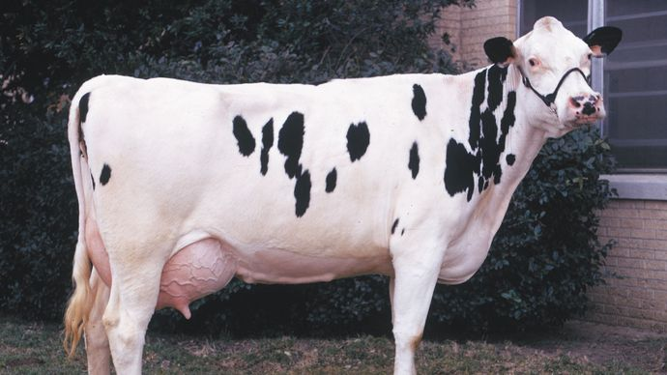

[Buffalo](https://www.britannica.com/animal/buffalo-mammal)’s milk is produced in commercial quantities in some countries, particularly [India](https://www.britannica.com/place/India). Where it is produced, buffalo’s milk is used in the same way as is cow’s milk, and in some areas the [community](https://www.merriam-webster.com/dictionary/community) milk supply consists of a mixture of both. This article treats the principles and practices of dairy farming.

Dairy cows are divided into five major breeds: Ayrshire, Brown Swiss, Guernsey, Holstein–Friesian, and Jersey. There are many minor breeds, among them the Red Dane, the Dutch Belted, and the Devon. There are also dual-purpose breeds used to produce milk and meat, notably the Milking Shorthorn and the Red Polled.

## [**Breeding**](https://www.britannica.com/science/animal-breeding)**and herd improvement.**

The breeds of dairy [cattle](https://www.britannica.com/animal/cattle-livestock) have been established by years of careful selection and mating of animals to [attain](https://www.britannica.com/dictionary/attain) desired types. Increased milk and butterfat production has been the chief objective, although the objective often has shifted to increased milk and protein production. Production per cow varies with many environmental factors, but the genetic background of the cow is extremely important.

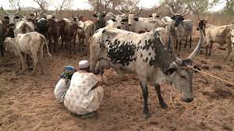 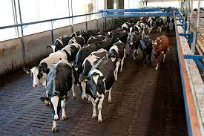

The principles of breeding to improve production have been helpful in increasing milk production in lesser developed countries. Progress has also been made in India with cows and water buffalo.

[**Artificial**](https://www.britannica.com/science/artificial-insemination)breeding has developed into a worldwide practice. Bulls with the genetic capacity to transmit high milk-producing ability to their female offspring are kept in studs. Dairy-farmer cooperatives usually operate the studs, with [artificial insemination](https://www.britannica.com/science/artificial-insemination) generally used. Semen for artificial insemination may be frozen for shipment to any part of the world.

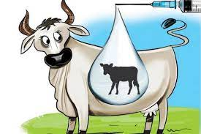 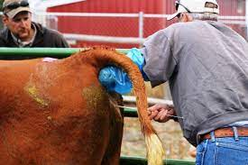

## **Feeding dairy cattle**

The dairy cow is an efficient producer of human [food](https://www.britannica.com/topic/food) from roughage. This ability is attributable to a [unique](https://www.britannica.com/dictionary/unique) digestive system that consists of a four-compartment stomach capable of handling roughages not digested by human beings and other monogastric (one-stomached) animals.

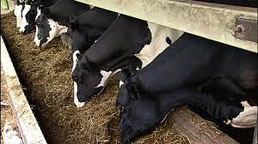

[Pasture](https://www.britannica.com/topic/pasture) is the natural [feed](https://www.britannica.com/topic/feed-agriculture) for dairy cattle, and an abundance of good pasture provides most of the requirements of a good dairy ration. An Feeding a balanced ration, however, rather than grass alone, increases milk production. By 2000 the average annual production per cow in New Zealand was 8,655 pounds (3,926 kilograms) of milk, while in the [U.S](https://www.britannica.com/place/United-States)., where supplemental feeding is common, it was 18,204 pounds, or 8,257 kilograms. Pastures of poor quality must be supplemented with other feed, such as green crops, summer [silage](https://www.britannica.com/topic/silage), or [hay](https://www.britannica.com/topic/hay-animal-feed).

During seasons when pastures are inadequate, cows need hay, silage, and grain in sufficient amounts and balance to supply nutrient needs, and to guarantee a nutritional reserve to keep milk volume and [composition](https://www.merriam-webster.com/dictionary/composition) from declining.

## [**Disease**](https://www.britannica.com/science/animal-disease)**prevention**

Disease is one of the greatest problems of the dairy farm. It is a constant threat and may make removal of valuable animals from the herd necessary when they show even a possibility of disease. One study of removal of cows from a typical dairy herd showed that slightly more than one in five were removed yearly and about a third of these were lost.

Certain diseases, such as tuberculosis, require injections. Others, such as mastitis, require constant treatment. For some diseases there is no known cure; slaughter of the animal is the only way to stop spread of the

infection. Foot and mouth disease is the most [notorious](https://www.merriam-webster.com/dictionary/notorious) of these; severe measures have been employed by most governments in order to exclude or control this disease.

## 

## **Milking and bulk handling on the farm**

The development of milk-producing tissue in the mammae is triggered by conception; minimal production begins in the seventh or eighth week, but secretion is [inhibited](https://www.merriam-webster.com/dictionary/inhibited) until after calving. The stimulus of calving increases [lactation](https://www.britannica.com/science/lactation) for several weeks, until another [conception](https://www.merriam-webster.com/dictionary/conception) prompts a gradual decline. In response to pregnancy hormones and the needs of the fetus, the animal is usually dry for the month or two preceding calving.

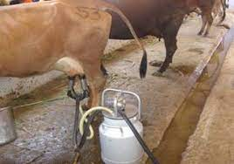 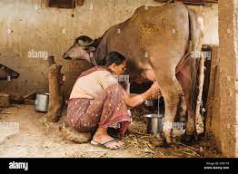

Milk is produced by the cow from her blood, and a large amount of food is necessary for maintenance of a high producing cow. There the raw materials are collected and changed into milk components. Each time the blood passes through the udder a small fraction of the components is removed to make the milk. A daily flow through the udder of 10 tons (20,000 pounds, or about 9,000 kilograms) of blood is required for a cow producing 50 pounds (22.5 kilograms) of milk per day. The energy required to produce milk components and to circulate the blood indicates the great importance of proper and [abundant](https://www.britannica.com/dictionary/abundant) feed.

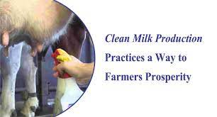

Today, most milking is done with machines by a carefully trained operator, usually twice a day, in stanchion barns or milking parlours. An experienced milker handles one to three machine units. The cows are first cleaned, and the teat cups put on. A pulsating vacuum draws the milk into a receiver or through piping into the farm milk tank.

Milk is an extremely perishable commodity that must be cooled to 50 °F (10 °C) or less within two hours. It then must be maintained at that temperature until it is delivered to the consumer.Milk is transported from farm to plant in a variety of ways, depending on the part of the world The receiving station transports the milk in large cans to the plant by truck.

In the major milk-producing countries of the world, the milk is held cold in the farm tank or in cans until it is picked up, usually once or twice daily, by tanker or truck. Tankers pump the milk in at the farm and out into plant tanks on delivery. The tanker [driver](https://www.britannica.com/dictionary/driver) measures and samples each farmer’s milk; fat and bacteria tests are run at the plant. The use of [pipelines](https://www.britannica.com/technology/pipeline-technology) has been introduced on a small scale in some European countries for delivery of milk from farm to factory.

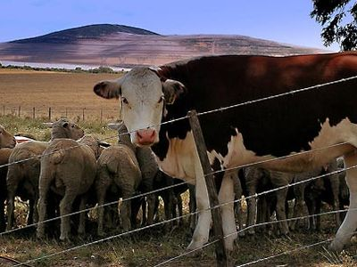

**livestock**, farm animals, with the exception of [poultry](https://www.britannica.com/animal/poultry-agriculture). In Western countries the category [encompasses](https://www.merriam-webster.com/dictionary/encompasses) primarily cattle, sheep, pigs, goats, horses, donkeys, and mules; other animals, such as buffalo, oxen, llamas, or camels, may predominate in the [agriculture](https://www.britannica.com/topic/agriculture) of other areas. Estimates suggest that the [mass](https://www.britannica.com/science/mass-physics) of [Earth](https://www.britannica.com/place/Earth)’s livestock, some 100 million metric tons (about 110 million tons), is more than that of [human beings](https://www.britannica.com/topic/human-being), wild [birds](https://www.britannica.com/animal/bird-animal), and wild [mammals](https://www.britannica.com/animal/mammal) put together.

**Poultry Farming**

Poultry farming is the form of animal husbandry which raises domesticated birds such as chickens, ducks, turkeys and geese to produce meat or eggs for food. Poultry – mostly chickens – are farmed in great numbers. More than 60 billion chickens are killed for consumption annually. **poultry farming**, raising of birds domestically or commercially, primarily for meat and [eggs](https://www.britannica.com/topic/egg-food) but also for feathers.

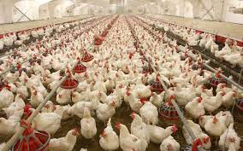

[Chickens](https://www.britannica.com/animal/chicken), [turkeys](https://www.britannica.com/animal/turkey-bird), [ducks](https://www.britannica.com/animal/duck), and [geese](https://www.britannica.com/animal/goose-bird) are of primary importance, while [guinea fowl](https://www.britannica.com/animal/guinea-fowl) and [squabs](https://www.britannica.com/animal/squab) (young pigeons) are chiefly of local interest. This article treats the principles and practices of poultry [farming](https://www.britannica.com/topic/agriculture). For a discussion of the [food](https://www.britannica.com/topic/food) [value](https://www.britannica.com/dictionary/value) and processing of [poultry](https://www.britannica.com/animal/poultry-agriculture) products, see [egg](https://www.britannica.com/topic/egg-food) and [poultry processing](https://www.britannica.com/technology/poultry-processing).

**Commercial production**

**Feeding**

Commercial poultry feeding is a highly perfected science that ensures a maximum intake of energy for growth and fat production. High-quality and well-balanced [protein](https://www.britannica.com/science/protein) sources produce a maximum amount of muscle, organ, skin, and [feather](https://www.britannica.com/science/feather) growth. The essential minerals produce bones and eggs, with about 3 to 4 percent of the live bird being composed of minerals and 10 percent of the egg.

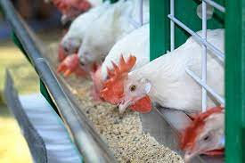 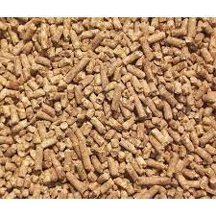

[Calcium](https://www.britannica.com/science/calcium), [phosphorus](https://www.britannica.com/science/phosphorus-chemical-element), [sodium](https://www.britannica.com/science/sodium), [chlorine](https://www.britannica.com/science/chlorine), [potassium](https://www.britannica.com/science/potassium), [sulfur](https://www.britannica.com/science/sulfur), [manganese](https://www.britannica.com/science/manganese), [iron](https://www.britannica.com/science/iron-chemical-element), [copper](https://www.britannica.com/science/copper), [cobalt](https://www.britannica.com/science/cobalt-chemical-element), [magnesium](https://www.britannica.com/science/magnesium), and [zinc](https://www.britannica.com/science/zinc) are all required. Vitamins [A](https://www.britannica.com/science/vitamin-A), [C](https://www.britannica.com/science/vitamin-C), [D](https://www.britannica.com/science/vitamin-D), [E](https://www.britannica.com/science/vitamin-E), and [K](https://www.britannica.com/science/vitamin-K) and all of the [B vitamins](https://www.britannica.com/science/vitamin-B-complex) are also required. [Antibiotics](https://www.britannica.com/science/antibiotic) are widely used to stimulate appetite, control harmful [bacteria](https://www.britannica.com/science/bacteria), and prevent disease.

[**Management**](https://www.britannica.com/topic/farm-management)

Birds are usually housed in wire cages with two or three animals per cage, depending on the species and breed, and three or four tiers of cages superposed to save space. Cages for egg-laying birds have been found to increase production, lower mortality, reduce cannibalism, lower feeding requirements, reduce diseases and [parasites](https://www.britannica.com/science/parasitism), improve [culling](https://www.britannica.com/dictionary/culling), and reduce both space and labour requirements

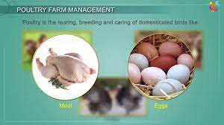 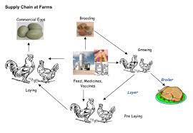

[Poultry breeding](https://www.britannica.com/science/animal-breeding) is an outstanding example of the application of basic genetic principles of [inbreeding](https://www.britannica.com/science/inbreeding) and [crossbreeding](https://www.britannica.com/science/animal-breeding/Breeding-systems#ref273127) as well as of intensive mass selection to effect faster and cheaper gains in meat and maximum egg production for the egg-laying strains. Rapid and efficient weight gains and high-quality, plump, meaty carcasses have been achieved thereby.

Among the world’s agricultural industries, [chicken](https://www.britannica.com/animal/chicken) breeding in the U.S. is one of the most advanced. Intensive nutritional research and application, highly improved breeding stock, intelligent management, and scientific disease control have gone into the effort to give a modern broiler (meat chicken) of uniformly high quality produced at ever-lower cost.

**Diseases**

Poultry are quite [susceptible](https://www.britannica.com/dictionary/susceptible) to a number of diseases. Some of the more common are fowl typhoid, pullorum, fowl cholera, chronic [respiratory disease](https://www.britannica.com/science/respiratory-disease), infectious sinusitis, infectious coryza, avian infectious hepatitis, infectious synovitis, bluecomb, [Newcastle disease](https://www.britannica.com/science/Newcastle-disease), fowl pox, avian leukosis complex, [coccidiosis](https://www.britannica.com/science/coccidiosis), [blackhead](https://www.britannica.com/science/blackhead-bird-disease), infectious laryngotracheitis, infectious bronchitis, and [erysipelas](https://www.britannica.com/science/erysipelas). Strict sanitary precautions, the intelligent use of antibiotics and [vaccines](https://www.britannica.com/science/vaccine), and the widespread use of cages for layers and confinement rearing for broilers have made it possible to effect satisfactory disease control.

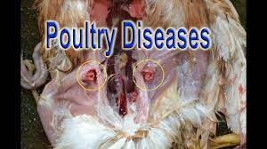 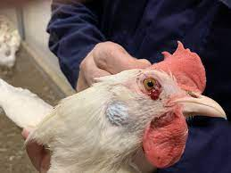

Outbreaks of [bird flu](https://www.britannica.com/science/bird-flu), or avian influenza, which was first detected in humans in 1997, have led to the culling of millions of poultry animals since the late 20th century. [Waterfowl](https://www.britannica.com/animal/waterfowl-bird) such as wild ducks are thought to be primary hosts for all bird flu subtypes. Though normally resistant to the [viruses](https://www.britannica.com/science/virus), the birds carry them in their intestines and distribute them through [feces](https://www.britannica.com/science/feces) into the environment, where they infect susceptible domestic birds. Sick birds pass the viruses to healthy birds through [saliva](https://www.britannica.com/science/saliva), nasal secretions, and feces. Within a single region, bird flu is [transmitted](https://www.britannica.com/dictionary/transmitted) readily from farm to farm by airborne feces-contaminated dust and [soil](https://www.britannica.com/science/soil), by contaminated clothing, feed, and equipment, or by wild animals carrying the [virus](https://www.britannica.com/science/virus) on their bodies. The disease is spread from region to region by migratory birds and through international trade in live poultry. Humans who are in close contact with sick birds—Again, modern methods of sanitation, prevention, and treatment provide excellent control.

**Types of poultry**

[**Chickens**](https://www.britannica.com/animal/chicken)

Mass production of [chicken](https://www.britannica.com/animal/chicken) meat and eggs began in the early 20th century, but by the middle of that century meat production had outstripped egg production as a specialized industry. The market for chicken meat has grown dramatically since then, with worldwide exports reaching nearly 12.5 million metric tons (about 13.8 million tons) by the early 21st century

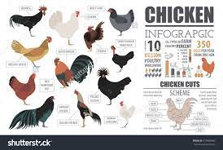

The breeds of chickens are generally classified as American, Mediterranean, English, and Asiatic. While there are hundreds of breeds in existence, commercial facilities rely on only a select few that meet the rigorous demands of industrial production. Small farms and backyard flocks utilize a much wider variety of breeds and hybrids.

**Broilers Chickens**

These chickens are raised to be slaughtered and eaten. Some of the most popular breeds of broiler chickens grow so quickly that they reach an average slaughter weight of  [**6.2 pounds**](https://downloads.usda.library.cornell.edu/usda-esmis/files/3197xm04j/n009w967m/2v23w3090/psla0419.pdf) in just a matter of weeks This vast disparity in growth is because of breeding that selects for growth rate and size at the expense of welfare.

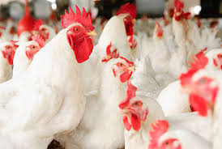

**Laying Chickens**

Laying hens are those that are raised to produce eggs. These hens often spend their lives in cages barely larger than they are. During their short life of [**72 weeks**](https://www.theguardian.com/environment/2016/apr/24/real-cost-of-roast-chicken-animal-welfare-farms), birds lay upwards of 320 eggs. This is despite their ability to live much longer productive lives of roughly four years if left to lay at a slower, more natural rate.

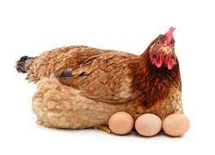

**Intelligence**

[**Chickens**](https://sentientmedia.org/are-chickens-smart/) have surprised scientists with their high levels of intelligence. They have been found to be curious and manipulative, to learn quickly, and can even do basic arithmetic. Further, chickens have unique personalities with some even [**purring from contentment**](https://freefromharm.org/farm-animal-intelligence/did-you-know-that-chickens-purr-when-theyre-content/) when they are being petted by a person that they trust.

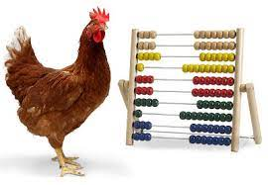

## **Turkeys**

Modern turkey breeding and [farming](https://www.britannica.com/topic/agriculture) practices have significantly reduced both the amount of [feed](https://www.britannica.com/topic/feed-agriculture) and the time required to produce a pound of turkey meat. In 12–14 weeks a hen turkey eats about 16 kg (35 pounds) of feed and reaches 6–9 kg (14–20 pounds). Turkeys can be raised on open land with automatic waterers, self-feeders, range shelters, heavy fencing, and rotated pastures; however, they are often “grown out” commercially in rearing houses under environmentally controlled conditions.

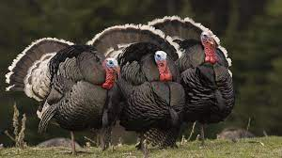

## [**Ducks**](https://www.britannica.com/animal/duck)**and geese**

[Duck](https://www.britannica.com/animal/duck) raising is practiced on a limited scale in nearly all countries, usually as a small-farm enterprise, though some commercial plants do exist. Ducks are easily transported, can be raised in close confinement, and [convert](https://www.britannica.com/dictionary/convert) some waste products and scattered grain to nutritious and very desirable [eggs](https://www.britannica.com/topic/egg-food) and meat.

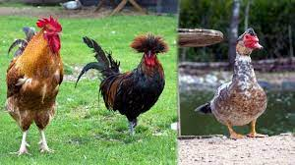

[Goose](https://www.britannica.com/animal/goose-bird) raising is often a minor farm enterprise, though some European countries have large-scale goose-production facilities. The birds are raised for meat and eggs as well as for their down [feathers](https://www.britannica.com/science/feather). Geese do not appear to have attracted the attention of geneticists on the same scale as the meat chicken and the turkey, and no change in the goose industry [comparable](https://www.britannica.com/dictionary/comparable) to that in the others has occurred or seems to be in prospect.

[**Guinea fowl**](https://www.britannica.com/animal/guinea-fowl)**and squabs**

[Guinea fowl](https://www.britannica.com/animal/guinea-fowl) are raised as a sideline on a few farms in many countries and are eaten as gourmet items. In Italy there is a fairly extensive industry. Guinea fowl are marketed in England at 16–18 weeks of age and in the United States at about 10–12 weeks. Squab production, carried on locally, is rare in most countries with established [poultry](https://www.britannica.com/animal/poultry-agriculture) industries, though the meat is often marketed as a gourmet item.

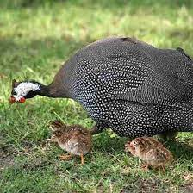 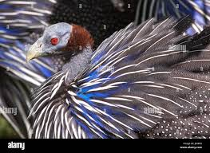

# **Poultry agriculture**

**poultry**, in [animal husbandry](https://www.britannica.com/science/animal-husbandry), [birds](https://www.britannica.com/animal/bird-animal) raised commercially or domestically for [meat](https://www.britannica.com/topic/meat), [eggs](https://www.britannica.com/topic/egg-food), and [feathers](https://www.britannica.com/science/feather). [Chickens](https://www.britannica.com/animal/chicken), [ducks](https://www.britannica.com/animal/duck), [turkeys](https://www.britannica.com/animal/turkey-bird), and [geese](https://www.britannica.com/animal/goose-bird) are of primary commercial importance, while [guinea fowl](https://www.britannica.com/animal/guinea-fowl) and [squabs](https://www.britannica.com/animal/squab) are chiefly of local interest. Based on the number of animals, poultry represent the largest domestic animal stock in the world, and poultry meat was the fastest growing component of global meat production in the early 21st century.

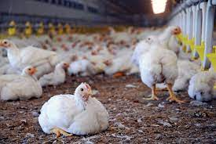

Poultry meat and eggs provide affordable high-quality protein. Poultry farming, especially on a small scale, is renewable and efficient and can provide a ready source of income and [nutrition](https://www.britannica.com/science/nutrition). See also [poultry farming](https://www.britannica.com/topic/poultry-farming) and [poultry processing](https://www.britannica.com/technology/poultry-processing)

**Techniques of Poultry Farming**

**Laying Hens**

### 

The methods by which vast numbers of eggs are produced every year entail serious suffering for millions of laying hens.

**Male chicks**

Because they are not able to lay eggs, male chicks are not needed for the industry. This results in the [**slaughter of 300 million baby chicks**](https://www.vox.com/future-perfect/22374193/eggs-chickens-animal-welfare-culling) every year in the U.S. alone and more than 6 billion worldwide.

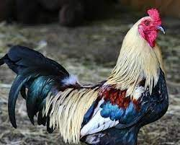

These chicks are most commonly either gassed or macerated, meaning crushed. They are not raised and used for meat because their small adult size would not be worth enough to offset the cost of feeding them into adulthood.

**Beak Trimming**

Within the first few days of life female chicks have their [**beaks trimmed**](https://kb.rspca.org.au/knowledge-base/what-is-beak-trimming-and-why-is-it-carried-out/). This process involves the removal of the tip of the beak to prevent the birds from pecking at each other. However, the procedure can cause both acute and chronic pain and also has lasting impacts on the birds’ ability to behave naturally.

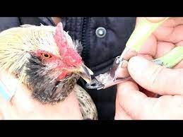 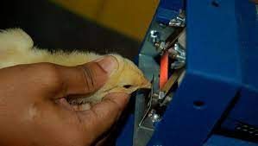

**Battery Cages**

Laying hens are overwhelmingly [**housed in cages**](https://www.humanesociety.org/resources/cage-free-vs-battery-cage-eggs) around the world. On average each hen has less space than an A4 sheet of paper in which to move around, preventing them from even spreading their wings. This lack of space makes a number of natural behaviors impossible, including nesting, perching, and dustbathing.

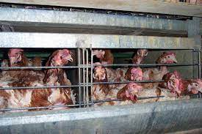 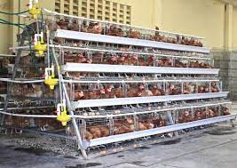

**Growth Rate-**

Broiler chickens grow at an astonishing [**65 grams or more a day**](https://edis.ifas.ufl.edu/publication/VM099) in order to reach their slaughter weight of 6.2 pounds in just a matter of weeks. This excessive growth leads to [**painful consequences**](https://www.goodheartanimalsanctuaries.com/wp-content/uploads/2021/01/Broiler-hen-factsheet.pdf)for the birds who often are not able to stand or walk normally as their legs struggle to support their ballooning size. The quick rate of growth also contributes

to organ problems due to the extra tolls being placed on the young chickens’ hearts and lungs.

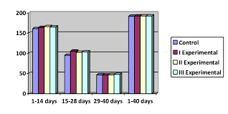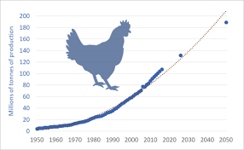

**Slaughter**

The most common method of slaughter for broiler chickens is [**live shackle slaughter**](https://thehumaneleague.org/article/the-time-to-end-live-shackle-slaughter-is-now). This method involves hanging chickens upside down in shackles on a mechanized slaughter line running at speeds of up to 175 birds per minute. This leads to many animals being incorrectly hung and consequently having their limbs mangled or losing them altogether.

The disassembly line then continues to an electrified water bath that is intended to stun the birds. Yet, many birds are ineffectively stunned or miss the bath completely, meaning that they are fully conscious when their throats are sliced open, surrounded by the frightened sounds of their flock.

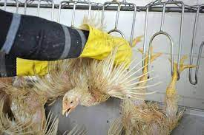 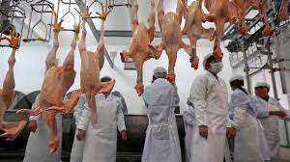

### Hatchery

Hatcheries are where most chickens begin their lives. Eggs are removed from the mother birds and placed into incubators. PETA found that at a commercial hatchery in India many [**chicks hatched with deformities**](https://investigations.peta.org/chicks-drowned-burned-crushed-india/), including some with organs outside of their bodies.

### 

**Fish Farming**

**Fish farming** or **pisciculture** involves commercial [breeding](https://en.wikipedia.org/wiki/Animal_husbandry) of [fish](https://en.wikipedia.org/wiki/Fish), usually for [food](https://en.wikipedia.org/wiki/Food), in [fish tanks](https://en.wikipedia.org/wiki/Fish_tank) or artificial [enclosures](https://en.wikipedia.org/wiki/Pen_(enclosure)) such as [fish ponds](https://en.wikipedia.org/wiki/Fish_pond).***.*** It is a particular type of [aquaculture](https://en.wikipedia.org/wiki/Aquaculture), which is the controlled cultivation and [harvesting](https://en.wikipedia.org/wiki/Fishing) of [aquatic animals](https://en.wikipedia.org/wiki/Aquatic_animal) such as fish, [crustaceans](https://en.wikipedia.org/wiki/Crustacean), [molluscs](https://en.wikipedia.org/wiki/Mollusc) and so on, in [natural](https://en.wikipedia.org/wiki/Natural_environment) or pseudo-natural environment

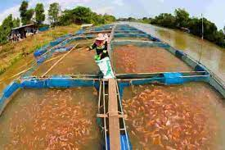 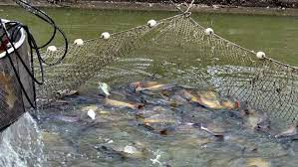

A facility that releases [juvenile fish](https://en.wikipedia.org/wiki/Juvenile_fish) into the wild for [recreational fishing](https://en.wikipedia.org/wiki/Recreational_fishing) or to supplement a species' natural numbers is generally referred to as a [fish hatchery](https://en.wikipedia.org/wiki/Fish_hatchery). Worldwide, the most important fish [species](https://en.wikipedia.org/wiki/Species) produced in fish farming are [carp](https://en.wikipedia.org/wiki/Carp), [catfish](https://en.wikipedia.org/wiki/Catfish), [salmon](https://en.wikipedia.org/wiki/Salmon) and [tilapia](https://en.wikipedia.org/wiki/Tilapia).

**Major species**

| **Top 15 cultured fish species by weight, according to**[**FAO**](https://en.wikipedia.org/wiki/FAO)**statistics for 2013**[[1]](https://en.wikipedia.org/wiki/Fish_farming#cite_note-FAO-1) | | | |
| --- | --- | --- | --- |
| **Species** | **Environment** | **Tonnage (millions)** | **Value (US$ billions)** |
| [Grass carp](https://en.wikipedia.org/wiki/Grass_carp) | Freshwater | 5.23 | 6.69 |
| [Silver carp](https://en.wikipedia.org/wiki/Silver_carp) | Freshwater | 4.59 | 6.13 |
| [Catla](https://en.wikipedia.org/wiki/Catla) (Indian carp) | Freshwater | 2.76 | 5.49 |
| [Crucian carp](https://en.wikipedia.org/wiki/Crucian_carp) | Freshwater | 2.45 | 2.67 |
| [Atlantic salmon](https://en.wikipedia.org/wiki/Atlantic_salmon) | Marine | 2.07 | 10.10 |
| [Roho labeo](https://en.wikipedia.org/wiki/Roho_labeo) | Freshwater | 1.57 | 2.54 |
| [Milkfish](https://en.wikipedia.org/wiki/Milkfish) | Marine | 0.94 | 1.71 |
| [Rainbow trout](https://en.wikipedia.org/wiki/Rainbow_trout) | * Freshwater * Brackish * Marine | 0.88 | 3.80 |
| [Wuchang bream](https://en.wikipedia.org/wiki/Wuchang_bream) | Freshwater | 0.71 | 1.16 |
| [Black carp](https://en.wikipedia.org/wiki/Black_carp) | Freshwater | 0.50 | 1.15 |
| [Northern snakehead](https://en.wikipedia.org/wiki/Northern_snakehead) | Freshwater | 0.48 | 0.59 |

|  |  |
| --- | --- |
| **Optimal water parameters for cold- and warm-water fish in intensive aquaculture**[[7]](https://en.wikipedia.org/wiki/Fish_farming#cite_note-7) | |
| **Parameter** | **Optimal value** |
| [Acidity](https://en.wikipedia.org/wiki/Acidity) | pH 6–9 |
| [Arsenic](https://en.wikipedia.org/wiki/Arsenic) | < 440 µg/L |
| [Alkalinity](https://en.wikipedia.org/wiki/Alkalinity) | > 20 mg/L (as CaCO3) |
| [Aluminium](https://en.wikipedia.org/wiki/Aluminium) | < 0.075 mg/L |
| [Ammonia](https://en.wikipedia.org/wiki/Ammonia) (non-ionized) | < 0.02 mg/L |
| [Cadmium](https://en.wikipedia.org/wiki/Cadmium) | * < 0.0005 mg/L in [soft water](https://en.wikipedia.org/wiki/Soft_water) * < 0.005 mg/L in [hard water](https://en.wikipedia.org/wiki/Hard_water) |
| [Calcium](https://en.wikipedia.org/wiki/Calcium) | > 5 mg/L |
| [Carbon dioxide](https://en.wikipedia.org/wiki/Carbon_dioxide) | < 5–10 mg/L |
| [Chloride](https://en.wikipedia.org/wiki/Chloride) | > 4.0 mg/L |
| [Chlorine](https://en.wikipedia.org/wiki/Chlorine) | < 0.003 mg/L |
| [Copper](https://en.wikipedia.org/wiki/Copper) | * < 0.0006 mg/L in soft water * < 0.03 mg/L in hard water |
| [Gas supersaturation](https://en.wikipedia.org/wiki/Supersaturation) | * < 100% total gas pressure * < 103% for salmonid eggs/fry * < 102% for lake trout |
| [Hydrogen sulfide](https://en.wikipedia.org/wiki/Hydrogen_sulfide) | < 0.003 mg/L |
| [Iron](https://en.wikipedia.org/wiki/Iron) | < 0.1 mg/L |
| [Lead](https://en.wikipedia.org/wiki/Lead) | < 0.02 mg/L |
| [Mercury](https://en.wikipedia.org/wiki/Mercury_(element)) | < 0.0002 mg/L |
| [Nitrate](https://en.wikipedia.org/wiki/Nitrate) | < 1.0 mg/L |
| [Nitrite](https://en.wikipedia.org/wiki/Nitrite) | < 0.1 mg/L |
| [Oxygen](https://en.wikipedia.org/wiki/Oxygen) | * 6 mg/L for coldwater fish * 4 mg/L for warmwater fish |
| [Selenium](https://en.wikipedia.org/wiki/Selenium) | < 0.01 mg/L |
| [Total dissolved solids](https://en.wikipedia.org/wiki/Total_dissolved_solids) | < 200 mg/L |
| Total [suspended solids](https://en.wikipedia.org/wiki/Suspended_solid) | < 80 [NTU](https://en.wikipedia.org/wiki/Nephelometric_Turbidity_Units) over ambient levels |
| [Zinc](https://en.wikipedia.org/wiki/Zinc) | < 0.005 mg/L |

## **Fish farms**

Within intensive and extensive aquaculture methods, numerous specific types of fish farms are used; each has benefits and applications unique to its design.

### Cage system

[**Giant gourami**](https://en.wikipedia.org/wiki/Giant_gourami) is often raised in cages in central Thailand.

Fish cages are placed in lakes, bayous, ponds, rivers, or oceans to contain and protect fish until they can be harvested.[[13]](https://en.wikipedia.org/wiki/Fish_farming#cite_note-scielo.br-13) The method is also called "off-shore cultivation"[[14]](https://en.wikipedia.org/wiki/Fish_farming#cite_note-14) when the cages are placed in the sea. They can be constructed of a wide variety of components. Fish are stocked in cages, artificially fed, and harvested when they reach market size. A few advantages of fish farming with cages are that many types of waters can be used (rivers, lakes, filled quarries, etc.), many types of fish can be raised, and fish farming can co-exist with sport fishing and other water uses.

### 

Cage farming of fishes in open seas is also gaining in popularity. Given concerns of disease, poaching, poor water quality, etc., generally pond systems are considered simpler to start and easier to manage. Also, the past occurrences of cage-failures leading to escapes, have raised concern regarding the culture of non-native fish species in dam or open-water cages. On August 22, 2017, there was a massive failure of such cages at a commercial fishery in Washington state in [Puget Sound](https://en.wikipedia.org/wiki/Puget_Sound), leading to release of nearly 300,000 Atlantic salmon in non-native waters. This is believed to risk endangering the native Pacific salmon species.

#### **Copper-alloy nets**

Recently, [copper alloys](https://en.wikipedia.org/wiki/Copper_alloys) have become important netting materials in [aquaculture](https://en.wikipedia.org/wiki/Aquaculture). Copper alloys are [antimicrobial](https://en.wikipedia.org/wiki/Antimicrobial), that is, they destroy [bacteria](https://en.wikipedia.org/wiki/Bacteria), [viruses](https://en.wikipedia.org/wiki/Viruses), [fungi](https://en.wikipedia.org/wiki/Fungi), [algae](https://en.wikipedia.org/wiki/Algae), and other [microbes](https://en.wikipedia.org/wiki/Microbes).

In the [marine environment](https://en.wikipedia.org/wiki/Marine_environment), the antimicrobial/algaecidal properties of copper alloys prevent [biofouling](https://en.wikipedia.org/wiki/Biofouling), which can briefly be described as the undesirable accumulation, adhesion, and growth of microorganisms, plants, [algae](https://en.wikipedia.org/wiki/Algae), [tube worms](https://en.wikipedia.org/wiki/Tube_worm_(body_plan)), [barnacles](https://en.wikipedia.org/wiki/Barnacles), [mollusks](https://en.wikipedia.org/wiki/Mollusks" \o "Mollusks), and other organisms

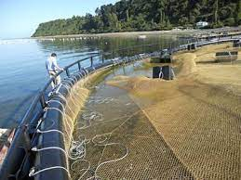

*Main article:*[*Copper alloys in aquaculture*](https://en.wikipedia.org/wiki/Copper_alloys_in_aquaculture)

Copper-zinc brass alloys are deployed in commercial-scale aquaculture operations in Asia, South America, and USA (Hawaii). Extensive research, including demonstrations and trials, are being implemented on two other copper alloys: copper-nickel and copper-silicon. Each of these alloy types has an inherent ability to reduce biofouling, cage waste, disease, and the need for antibiotics, while simultaneously maintaining water circulation and oxygen requirements. Other types of copper alloys are also being considered for research and development in aquaculture operations.

In [Southeast Asia](https://en.wikipedia.org/wiki/Southeast_Asia), the traditional cage farming platform is called [kelong](https://en.wikipedia.org/wiki/Kelong" \o "Kelong).

### Open net pen system –

The open net pens system is a method that takes place in natural waters, such as rivers, lakes, near the coast or offshore. The breeders rear the fish in large cages floating in the water. The fish are living in natural water but are isolated with a net. Because the only barrier separating the fish from the surrounding environment is a net, this allows the water to flow from the ‘natural’ surrounding through the fish farms.

### 

The site of the fish farm is crucial for the farm to be a success or not. Before any fish farm is settled, it is highly recommended to be selective with the site location of the farm. The site must be examined on some essential elements. Important conditions on the location are:

1. A good interchange of water and also a high replacement of bottom water.
2. At all depths should be a good current condition. This is necessary because the organic particles should be able to be carried away using the current.
3. A gravel and sand bottom are qualified for fish farming, although bottoms with silt and mud are not qualified. These should be avoided.
4. A net should be at least 10 metres (33 ft) or more above the bottom, so depth is important.

Despite these important site conditions, the open net pen method was very popular in Norway and China. This is because of the cost friendliness and efficiency of this method.

#### **Negative external effects**

Because of the ocean's water flow and other reasons, open net pen culture is seen as a high-risk method for the environment. The flow allows chemicals, parasites, waste and diseases to spread in the enclosed environment, and this is not beneficial for the natural environment. Another negative consequence is the high escape rate of the cultured fish from these open net pens. These escaped fish also pose a high risk to the surrounding ecosystems.

The amount of organic waste produced by fish farms is also alarming. A salmon farm in [Scotland](https://en.wikipedia.org/wiki/Scotland), for instance, is estimated to produce as much organic waste as equivalent to a town of people between 10,000 and 20,000 people each year.

Today 50% of the world's seafood is farm-raised.

### Irrigation ditch or pond systems

[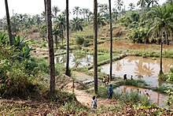](https://en.wikipedia.org/wiki/File:Community_fish-farming_ponds_in_the_rural_town_of_Masi_Manimba,_DRC_(7609946524).jpg)

These fish-farming ponds were created as a [cooperative](https://en.wikipedia.org/wiki/Cooperative) project in a rural village in the [Congo](https://en.wikipedia.org/wiki/Democratic_Republic_of_Congo).

These use [irrigation](https://en.wikipedia.org/wiki/Irrigation) ditches or farm ponds to raise fish. The basic requirement is to have a ditch or pond that retains water, possibly with an above-ground irrigation system (many irrigation systems use buried pipes with headers).

Using this method, water allotments can be stored in ponds or ditches, usually lined with [bentonite](https://en.wikipedia.org/wiki/Bentonite) clay. In small systems, the fish are often fed commercial fish food, and their waste products can help fertilize the fields. In larger ponds, the pond grows water plants and algae as fish food. Some of the most successful ponds grow introduced strains of plants, as well as introduced strains of fish.

Control of water quality is crucial. Fertilizing, clarifying, and [pH](https://en.wikipedia.org/wiki/PH) control of the water can increase yields substantially, as long as [eutrophication](https://en.wikipedia.org/wiki/Eutrophication) is prevented and oxygen levels stay high. Yields can be low if the fish grow ill from electrolyte stress.

### Integrated recycling systems

Aerators in a fish farm ([Ararat plain](https://en.wikipedia.org/wiki/Ararat_plain), [Armenia](https://en.wikipedia.org/wiki/Armenia))

One of the largest problems with freshwater pisciculture is that it can use a million gallons of water per acre (about 1 m3 of water per m2) each year. Extended [water purification](https://en.wikipedia.org/wiki/Water_purification) systems allow for the reuse ([recycling](https://en.wikipedia.org/wiki/Recycling)) of local water.

[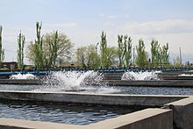](https://en.wikipedia.org/wiki/File:Unifish_fish_farm.JPG)

The largest-scale pure fish farms use a system derived (admittedly much refined) from the [New Alchemy Institute](https://en.wikipedia.org/wiki/New_Alchemy_Institute) in the 1970s. Basically, large plastic fish tanks are placed in a greenhouse. A [hydroponic](https://en.wikipedia.org/wiki/Hydroponic) bed is placed near, above or between them. When tilapia are raised in the tanks, they are able to eat algae, which naturally grow in the tanks when the tanks are properly fertilized.

The tank water is slowly circulated to the hydroponic beds, where the tilapia waste feeds commercial plant crops. Carefully cultured microorganisms in the hydroponic bed convert [ammonia](https://en.wikipedia.org/wiki/Ammonia) to [nitrates](https://en.wikipedia.org/wiki/Nitrate), and the plants are fertilized by the nitrates and [phosphates](https://en.wikipedia.org/wiki/Phosphate" \o "Phosphate).Other wastes are strained out by the hydroponic media, which double as an aerated pebble-bed filter.

Since the system lives in a [greenhouse](https://en.wikipedia.org/wiki/Greenhouse), it adapts to almost all temperate climates, and may also adapt to [tropical climates](https://en.wikipedia.org/wiki/Tropical_climate). The main environmental impact is discharge of water that must be salted to maintain the fishes' [electrolyte](https://en.wikipedia.org/wiki/Electrolyte) balance. Current growers use a variety of proprietary tricks to keep fish healthy, reducing their expenses for salt and wastewater discharge permits. Some veterinary authorities speculate that ultraviolet ozone disinfectant systems (widely used for ornamental fish) may play a prominent part in keeping the tilapia healthy with recirculated water.

### Classic fry farming

This is also called a "flow through system" .[[40]](https://en.wikipedia.org/wiki/Fish_farming#cite_note-40) Trout and other sport fish are often raised from eggs to [fry](https://en.wikipedia.org/wiki/Spawn_(biology)#Fry) or fingerlings and then trucked to streams and released. Normally, the fry are raised in long, shallow, concrete tanks, fed with fresh stream water. The fry receive commercial fish food in pellets. While not as efficient as the New Alchemists' method, it is also far simpler and has been used for many years to stock streams with sport fish. European eel ([*Anguilla anguilla*](https://en.wikipedia.org/wiki/Anguilla_anguilla)) aquaculturalists procure a limited supply of glass eels, juvenile stages of the European eel which swim north from the [Sargasso Sea](https://en.wikipedia.org/wiki/Sargasso_Sea) breeding grounds, for their farms.

### 

The issue of feeds in fish farming has been a controversial one. Many cultured fishes (tilapia, carp, catfish, many others) can be raised on a strictly herbivorous diet. Top-level carnivores (most [salmonidae](https://en.wikipedia.org/wiki/Salmonidae" \o "Salmonidae) species in particular) on the other hand, depend on fish feed, of which a large portion is usually derived from wild-caught fish ([anchovies](https://en.wikipedia.org/wiki/Anchovies), [menhaden](https://en.wikipedia.org/wiki/Menhaden), etc

Not only do the feeds for carnivorous fish, like certain salmon species, remain controversial due to the containment of wild caught fish like anchovies, but they are not helping the health of the fish, as is the case in Norway. Between 2003 and 2007, Aldrin et al., examined three infectious diseases in Norwegian salmon fish farms—heart and skeletal muscle inflammation, pancreas disease, and infectious salmon anemia.

### Stocking density

Secondly, farmed fish are kept in concentrations never seen in the wild (e.g. 50,000 fish in a 2-acre (8,100 m2) area.[]](https://en.wikipedia.org/wiki/Fish_farming#cite_note-48)). However, fish tend also to be animals that aggregate into large schools at high density. Most successful aquaculture species are schooling species, which do not have social problems at high density. Aquaculturists feel that operating a rearing system above its design capacity or above the social density limit of the fish will result in decreased growth rate and increased ratio.

### Parasites & disease

[Sea lice](https://en.wikipedia.org/wiki/Sea_lice), particularly *Lepeophtheirus salmonis* and various *Caligus* species, including *C. clemensi* and *C. rogercresseyi*, can cause deadly infestations of both farm-grown and wild salmon.[[50]](https://en.wikipedia.org/wiki/Fish_farming#cite_note-50)[[51]](https://en.wikipedia.org/wiki/Fish_farming#cite_note-51) Sea lice are [ectoparasites](https://en.wikipedia.org/wiki/Ectoparasite) which feed on mucus, blood, and skin, and migrate and latch onto the skin of wild salmon during free-swimming, planktonic *nauplii* and *copepodid* larval stages, which can persist for several days. Large numbers of highly populated, open-net salmon farms can create exceptionally large concentrations of sea lice; when exposed in river estuaries containing large numbers of open-net farms, many young wild salmon are infected, and do not survive as a result.[[55]](https://en.wikipedia.org/wiki/Fish_farming#cite_note-55)[[56]](https://en.wikipedia.org/wiki/Fish_farming#cite_note-56) Adult salmon may survive otherwise critical numbers of sea lice, but small, thin-skinned juvenile salmon migrating to sea are highly vulnerable.

### 

[Diseases and parasites](https://en.wikipedia.org/wiki/Fish_disease_and_parasites) are the most commonly cited reasons for such decreases. Some species of sea lice have been noted to target farmed coho and Atlantic salmon. Such parasites have been shown to have an effect on nearby wild fish. One place that has garnered international media attention is British Columbia's [Broughton Archipelago](https://en.wikipedia.org/wiki/Broughton_Archipelago).

Because of parasite problems, some aquaculture operators frequently use strong antibiotic drugs to keep the fish alive, but many fish still die prematurely at rates up to 30%. Additionally, other common drugs used in salmonid fish farms in North America and Europe include anesthetic, chemotherapeutic, and anthelmintic agents.[[65]](https://en.wikipedia.org/wiki/Fish_farming#cite_note-65) In some cases, these drugs have entered the environment.

The lice and pathogen problems of the 1990s facilitated the development of current treatment methods for sea lice and pathogens, which reduced the stress from parasite/pathogen problems. However, being in an ocean environment, the transfer of disease organisms from the wild fish to the aquaculture fish is an ever-present risk.

### Ecosystem impacts

The large number of fish kept long-term in a single location contributes to [habitat destruction](https://en.wikipedia.org/wiki/Habitat_destruction) of the nearby areas.[[71]](https://en.wikipedia.org/wiki/Fish_farming#cite_note-71) The high concentrations of fish produce a significant amount of condensed faeces, often contaminated with drugs, which again affects local waterways.

Aquaculture not only impacts the fish on the farm, but it also influences other species, which in return are attracted to or repelled by the farms.[[72]](https://en.wikipedia.org/wiki/Fish_farming#cite_note-:0-72) Mobile fauna, such as crustaceans, fish, birds, and marine mammals, interact with the process of aquaculture, but the long-term or ecological effects as a result of these interactions is still unknown. Some of these fauna may be attracted or demonstrate repulsion.

## **Indoor fish farming**

Other treatments such as ultraviolet sterilization, ozonation, and oxygen injection are also used to maintain optimal water quality. Through this system, many of the environmental drawbacks of aquaculture are minimized including escaped fish, water usage, and the introduction of pollutants. The practices also increased feed-use efficiency growth by providing optimum water quality.

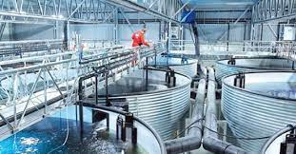

One of the drawbacks to recirculating aquaculture systems is the need for periodic water exchanges. However, the rate of water exchange can be reduced through [aquaponics](https://en.wikipedia.org/wiki/Aquaponics), such as the incorporation of hydroponically grown plants[[82]](https://en.wikipedia.org/wiki/Fish_farming#cite_note-82) and denitrification.

## **Slaughter methods**

Tanks saturated with carbon dioxide have been used to make fish unconscious. Their gills are then cut with a knife so that the fish bleed out before they are further processed. This is no longer considered a humane method of slaughter. Methods that induce much less physiological stress are electrical or percussive stunning and this has led to the phasing out of the carbon dioxide slaughter method in Europe.

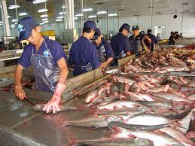

**Inhumane methods**

### 

According to T. Håstein of the National Veterinary Institute (Oslo, Norway), "Different methods for slaughter of fish are in place and it is no doubt that many of them may be considered as appalling from an animal welfare point of view."[[96]](https://en.wikipedia.org/wiki/Fish_farming#cite_note-FOOTNOTEH%C3%A5stein2004224-96) A 2004 report by the [EFSA](https://en.wikipedia.org/wiki/EFSA) Scientific Panel on Animal Health and Welfare explained: "Many existing commercial killing methods expose fish to substantial suffering over a prolonged period of time. For some species, existing methods, whilst capable of killing fish humanely, are not doing so because operators don't have the knowledge to evaluate them." Following are some less humane ways of killing fish.

* Air asphyxiation amounts to suffocation in the open air. The process can take upwards of 15 minutes to induce death, although unconsciousness typically sets in sooner.[[98]](https://en.wikipedia.org/wiki/Fish_farming#cite_note-FOOTNOTEBenson23-98)
* Ice baths or chilling of farmed fish on ice or submerged in near-freezing water is used to dampen muscle movements by the fish and to delay the onset of post-death decay. However, it does not necessarily reduce sensibility to pain; indeed, the chilling process has been shown to elevate [cortisol](https://en.wikipedia.org/wiki/Cortisol). In addition, reduced body temperature extends the time before fish lose consciousness.
* [CO2 narcosis](https://en.wikipedia.org/wiki/Hypercapnia)
* Exsanguination without stunning is a process in which fish are taken up from water, held still, and cut so as to cause bleeding. According to references in Yue,[[100]](https://en.wikipedia.org/wiki/Fish_farming#cite_note-FOOTNOTEYue6-100) this can leave fish writhing for an average of four minutes, and some catfish still responded to noxious stimuli after more than 15 minutes.
* Immersion in salt followed by gutting or other processing such as smoking is applied to eel.

**More humane methods**

Proper stunning renders the fish unconscious immediately and for a sufficient period of time such that the fish is killed in the slaughter process (e.g. through exsanguination) without regaining consciousness.

* Percussive stunning involves rendering the fish unconscious with a blow on the head.
* Electric stunning can be humane when a proper current is made to flow through the fish brain for a sufficient period of time. Electric stunning can be applied after the fish has been taken out of the water (dry stunning) or while the fish is still in the water.

## **Gallery**

* [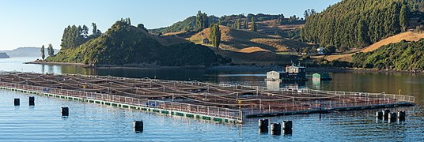](https://en.wikipedia.org/wiki/File:2019-03-16_01_Aquaculture_in_Chile.jpg)

Fish farming in the fjords of southern Chile

* [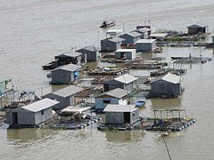](https://en.wikipedia.org/wiki/File:Fish-farms-vietnam.jpg)

Houseboat rafts with cages under for rearing fish near [Mỹ Tho](https://en.wikipedia.org/wiki/M%E1%BB%B9_Tho" \o "Mỹ Tho), Vietnam

* [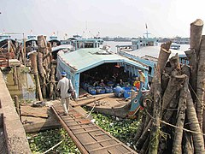](https://en.wikipedia.org/wiki/File:Fish-farming-vietnam.jpg)

Transport boats moored at fish processing plant, Mỹ Tho

* [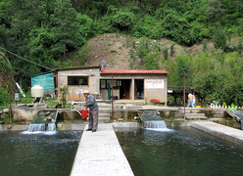](https://en.wikipedia.org/wiki/File:Zapotec_fish_farm_in_Ixtlan_Oaxaca.png)

Communal [Zapotec](https://en.wikipedia.org/wiki/Zapotec_peoples) fish farm in [Ixtlán de Juárez](https://en.wikipedia.org/wiki/Ixtl%C3%A1n_de_Ju%C3%A1rez" \o "Ixtlán de Juárez), Mexico

* [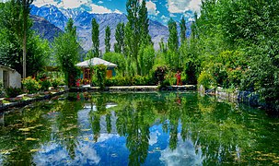](https://en.wikipedia.org/wiki/File:Fish_farm_Skardu.jpg)

Fish farming traditionally takes place in purpose-built tanks in the [Skardu](https://en.wikipedia.org/wiki/Skardu" \o "Skardu) region in northern [Pakistan](https://en.wikipedia.org/wiki/Pakistan).

* [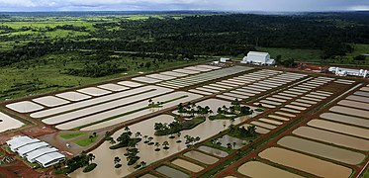](https://en.wikipedia.org/wiki/File:Complexo_de_Piscicultura_do_Acre.jpg)

Pisciculture Complex, outside [Rio Branco](https://en.wikipedia.org/wiki/Rio_Branco,_Acre), Brazil